**Project Proposal: Demographic Data Visualization Tool**

**The project is being developed by: Omar Sánchez Gudiño and Yahaira Vianney Farias Sanchez**

**1. Project Title:**

**Interactive Demographic Data Visualization Tool for Municipalities**

**2. Project Overview:**

This project aims to develop an interactive data visualization tool that allows users to explore and analyze the population demographics across different municipalities in Jalisco. Using a provided CSV dataset containing municipal population data, users will be able to visualize the population distribution based on selected municipalities, age ranges, and sex categories. The tool will be, interactive, and dynamic, providing clear insights into population trends across various age groups and regions.

**3. Motivation and Problem Statement:**

Population data is essential for government planning, urban development, healthcare services, and education. The ability to interactively explore population data across different municipalities is critical for decision-makers. Currently, accessing demographic data can be cumbersome, with static reports that lack interactivity. This project aims to bridge this gap by providing a flexible and user-friendly tool to visualize population demographics at a granular level.

**4. Objectives:**

* **Visualize population distribution** based on municipality, age range, and sex.
* Provide an **interactive user interface** to allow users to select specific municipalities, age ranges, and sex categories.
* Enable **dynamic data updates** where users can select multiple municipalities for comparison.
* Offer insights through **visual representations** like bar charts, showing the total population for selected parameters.

**5. Data Source:**

The tool will utilize a CSV dataset (conjunto_de_datos_iter_14CSV20.csv) containing demographic information from Mexican municipalities. Key columns in the dataset include:

* **NOM_MUN**: Municipality names.
* **Age range columns**: Columns representing various age groups (P_0A4, P_5A9, etc.).
* **SEX**: Sex classification (Male/Female).

**6. Key Features:**

* **Multiple Municipality Selection**: Users can select one or more municipalities to compare population data.
* **Age Range Filter**: Users can filter data by selecting specific age ranges, such as "0-4", "10-14", etc.
* **Sex Filter**: The ability to filter data based on sex (Male or Female).
* **Interactive Bar Graph**: Dynamic visualization updating in real-time based on user input.
* **Customizable Layout**: Users can select different parameters, and the graph will adjust accordingly, making comparisons easy.

**7. Technical Implementation:**

The project will be implemented using the following technologies:

* **Python**: The main programming language for data manipulation and web integration.
* **Pandas**: For data processing and manipulation.
* **Panel**: A Python library for creating interactive web-based applications.
* **Plotly**: For creating interactive bar graphs to visualize population data.
* **CSV Data Loading**: The demographic data will be loaded into a Pandas DataFrame for analysis.

**8. System Workflow:**

1. **Data Loading**: Load the CSV dataset containing municipal demographic data.
2. **User Selection**: Users will be presented with dropdowns and radio buttons to select municipalities, age ranges, and sex.
3. **Data Processing**: Based on the user’s selections, the tool will filter the dataset to extract the relevant population data.
4. **Visualization**: Display a bar graph representing the total population for each selected municipality and age range.
5. **Dynamic Updates**: The graph will update in real-time as users adjust the selections.
6. Will contain more objects for the user to check the process of the information (average, normal distribution, etc.)

**9. User Interface:**

The interface will consist of:

* A **multi-select widget** for choosing municipalities.
* A **dropdown menu** for selecting age ranges.
* A **radio button** for selecting the sex category.
* An **interactive bar chart** that updates based on user selections.
* Will contain more objects for the user to check the process of the information (average, normal distribution, etc.)

**10. Challenges and Considerations:**

* **Data Cleansing**: Ensure that the dataset is clean and handles invalid data entries (e.g., non-numeric values).
* **Performance**: Handle large datasets efficiently to avoid slow rendering of graphs.
* **User Experience**: Create a user-friendly interface that is intuitive and easy to navigate.

**11. Expected Outcomes:**

By the end of the project, users will have access to a fully functional and interactive tool to visualize population data, empowering stakeholders with actionable insights for policymaking, resource allocation, and planning.

**12. Timeline:**

* **Week 1**: Initial project setup, data loading, and cleaning.
* **Week 2**: Widget creation and basic layout design.
* **Week 3**: Implement data filtering logic and connect to Plotly for dynamic graphing.
* **Week 4**: Finalize the user interface, testing, and deployment.

**13. Interface so far:**

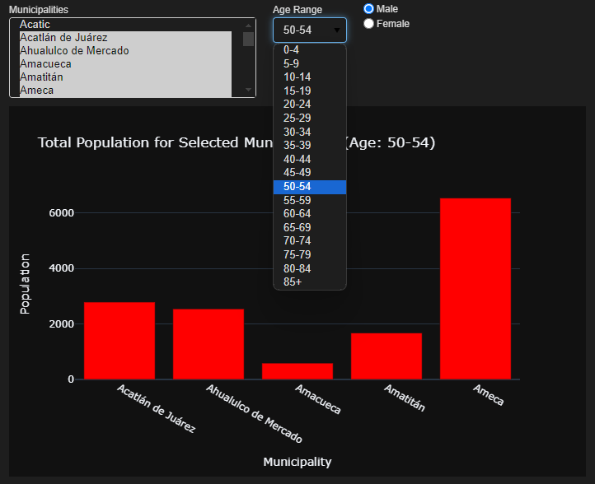

**14. Conclusion:**

This tool will be an asset for analyzing demographic data across municipalities, providing an interactive way to understand population distribution based on key variables such as age and sex, also will give an overview of the data but with some data processing. It will support data-driven decision-making for government agencies, researchers, and the public.